PROJECT SILENT BRIDGE
The aim of the project is to explore how a a single machine can be transformed into a dual layer Private Network Gateway by deploying for both WireGuard and OpenVPN side by side. The goal is to built a fast, resilient and stealth-capable secure communication tunnel while ensuring we have a grasp of modern VPN architecture. Each step from system preparation to traffic routing will reveal how this technologies behave, interact and compliment one another. The project not only encompass setting up a VPN software but also shaping the machine into a versatile security node that will combine speed, robustness and anonymity while using the internet.

Architecture Overview

Dual-VPN Gateway Concept
The system hosts two independent VPN environments:
- WireGuard
  - Subnet: 10.10.0.0/24
  - Port: 51820/udp
- OpenVPN
  - Subnet: 10.8.0.0/24
  - Port: 443/tcp (stealth under HTTPS-like traffic)

Why Two VPNs?
- Clean routing separation
- Avoid overlapping routes
- Easier debugging
- Stealth operation in restrictive networks
- Faster WireGuard performance + mature OpenVPN PKI stack
Phase one – System Preparations.
Your machine becomes a router.
To ensure for a stable and consistent environment the firsts tep is always running a system update and upgrade. in kali distro, the command sudo apt update && sudo apt full-upgrade -y should doit. The -y ensures that the system automatically answers yes to the prompts of if we wish to update… with that set we are guaranteed that the WireGuard, OpenVPN and the kernel-level networking components operate using the most recent stable versions.

Enabling IPv4 forwarding.
This transforms the kali machine into a gateway capable of routing the VPN traffic to external network. This step elevates the system from standard host to functional network router. To achieve this the command :

echo 'net.ipv4.ip_forward=1' | sudo tee /etc/sysctl.d/99-forwarding.conf
sudo sysctl -p /etc/sysctl.d/99-forwarding.conf is run.
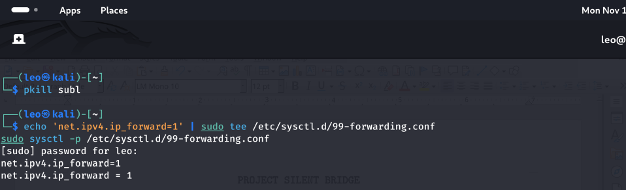

A successful output should be as net.ipv4.ip_forward = 1.
install and prepare the firewall:- Uncomplicated Firewall [UFW].
This step keeps the environment controlled by ensuring that OpenVPN and WireGuard get their own clean doorway/port.
The command sudo apt install ufw -y.
our preferred port of choice are port 51820/udp and port 444/tcp. To enable the ports and the firewall run the commands.
_{Sudo apt allow 51828/udp}
_{sudo ufw allow 443/tcp}
_{sudo ufw enable}
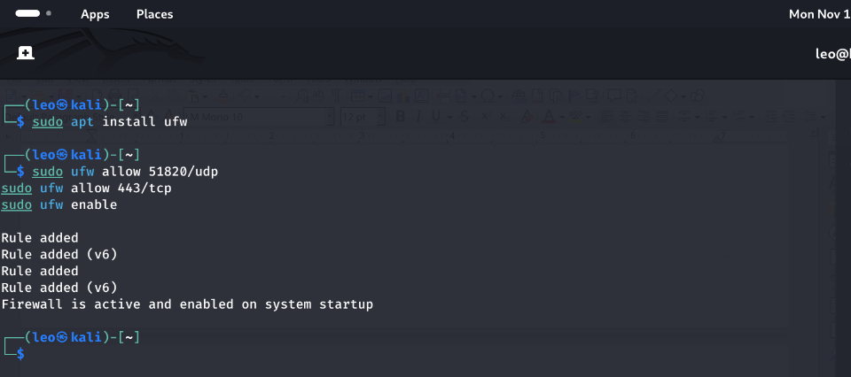

if a port is already running or allowed use the command sudo ufw delete allow <port/service>: assuming port 51820/udp is running the command sudo ufw delete allow 51820/udp. Then use the command sudo ufw allow <port/service> ie sudo ufw allow 51820/udp.

The above is set to allow/support clean traffic management with the use of the UFW [Uncomplicated Firewall] was configured to allow inbound VPN connections. Port 51820/udp was reserved for WireGuard while 443/tcp was allocated for OpenVPN for stealth operation over HTTP/S like traffic. The dual port setup ensures that both services can coexist without conflict.
The Network Blueprint.
The project is to use two independent virtual subnets to ensure clean routing separation. WireGuard will operate over the 10.10.0.0/24 network while OpenVPN is assigned the 10.20.1.0/24. this is to avoid overlapping routes as well as simplify debugging and traffic tracing. WireGuard is to listen on port 51820/udp, and OpenVPN is to run over port 443/TCP for improved stealth in restrictive environment.
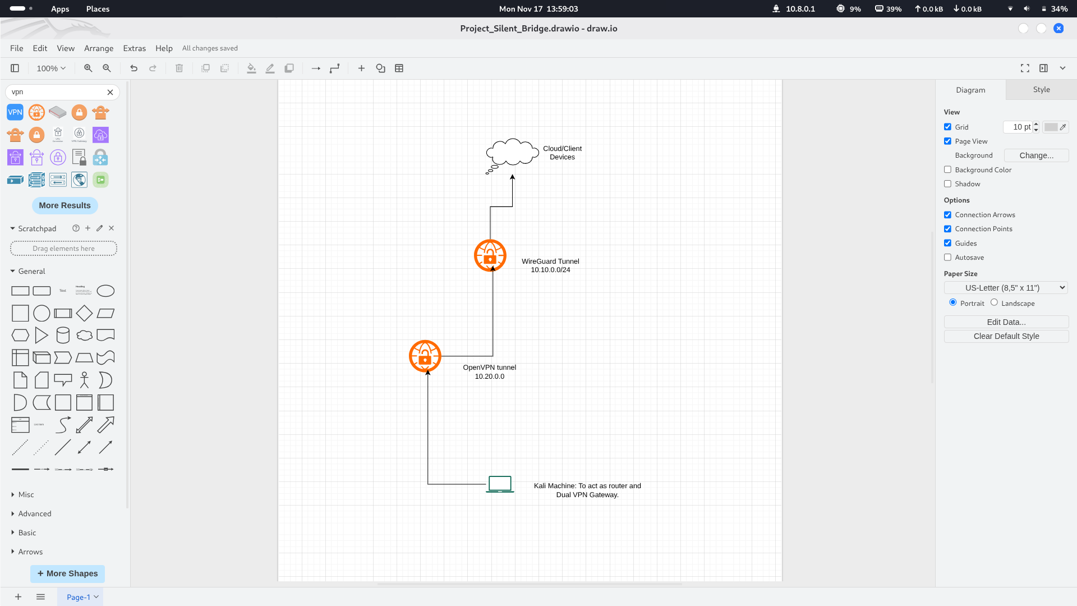
the diagram illustrates a visual map for our expected outcome.

WIREGUARD INSTALLATION AND SETUP

Phase 2: WireGuard Installation and Server Configuration.

Installing WireGuard.
The command sudo apt install WireGuard && sudo apt install WireGuard tools should do it.

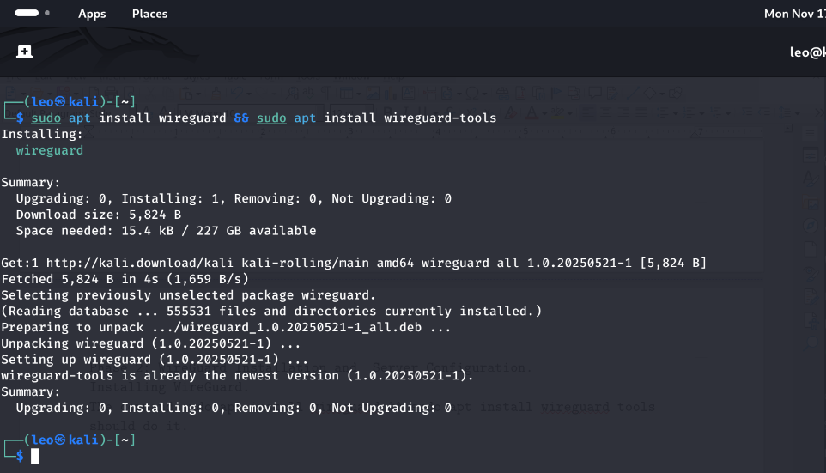

Generating Server Keys.

Navigate to the /etc/wireguard and generate the keys from the directory.
The command sudo wg genkey | sudo tee server_private.key | wg pubkey | sudo tee server_public.key
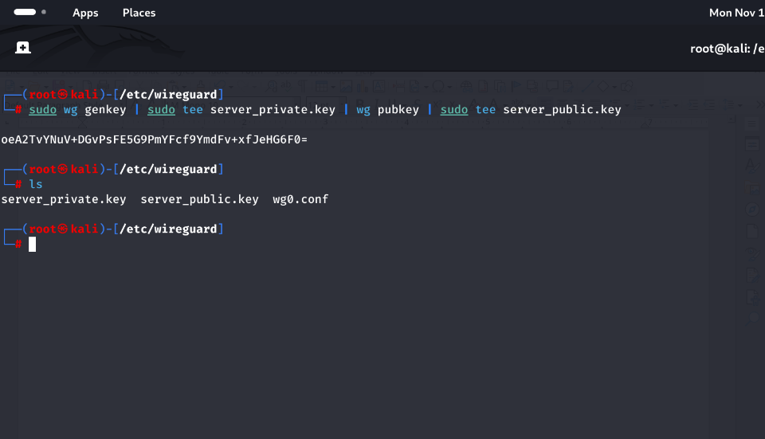

“WireGuard uses a simple public–private key model. The server’s key pair was generated in /etc/wireguard/, with strict permissions applied to protect the private key. These keys authenticate and encrypt all VPN communication.”

ensure to make the key readable to the root only with the command :
sudo chmod 600 server_private.key
this is done to ensure restrictive permissions as it contains our private key
creating a WireGuard Interface [wg0]
this step is where we build the server configurations.
We start by creating a file named wg0.conf in /etc/wireguard with the command
sudo nano /etc/wireguard/wg0/conf


in the wg0.conf inert

[Interface]
Address = 10.10.0.1/24
ListenPort = 51820
PrivateKey = <SERVER_PRIVATE_KEY>

# NAT rules for outbound traffic
PostUp = iptables -t nat -A POSTROUTING -o eth0 -j MASQUERADE
PostDown = iptables -t nat -D POSTROUTING -o eth0 -j MASQUERADE

“The primary WireGuard interface configuration (wg0) defines the server’s VPN IP, port, and routing rules. NAT masquerading is enabled through PostUp and PostDown directives, allowing VPN clients to reach external networks through the server’s primary interface.”
Start and Enable WireGuard interface.
The command
sudo wg-quick up wg0
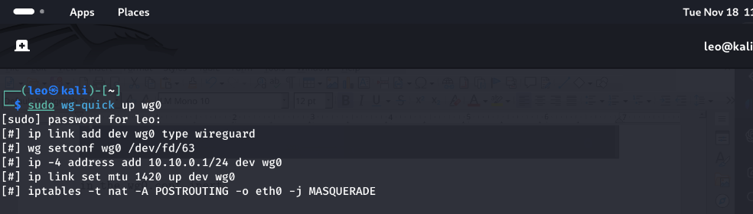

which starts WireGuard.

To enable on bootup
sudo systemctl enable wg-quick@wg0

to view status
sudo wg
where you should see something like.

interface: wg0
public key: ABC123...
private key: (hidden)
listening port: 51820
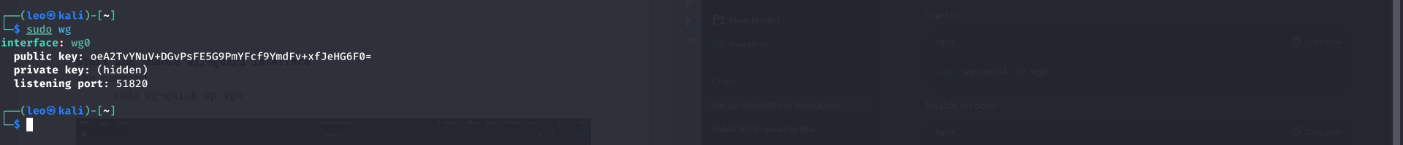

the WireGuard interface is activated in the command sudo wg-quick up wg0 and hence turning the configuration into a live VPN endpoint. And the command sudo systemctl enable wg-quick@wg0 ensures that the WireGuard starts on system startup/boot.
Phase 3: Generate Client keys

this phase ensures for
a working client keypair
- a client IP on the VPN subnet
- a full client.conf you can use on another device
- server ↔ client handshake verification

Generating client keys.

Generating for client privaye and public keys with the command
wg genkey | tee client1_privatekey | wg pubkey > client1_publickey

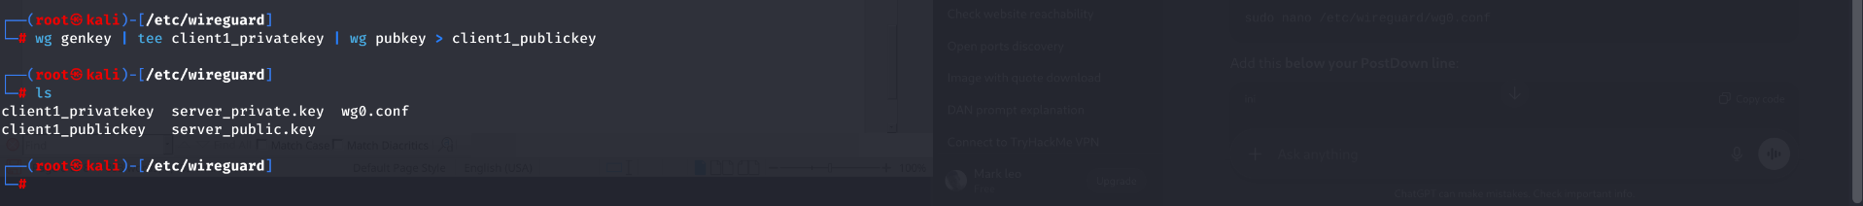
a dedicate key pair is generated for the WireGuard client. This is becauce WireGuard assigns identities based on key pairs thus enabling lightweight built and secure authentication.

Add the client as the peer to the server

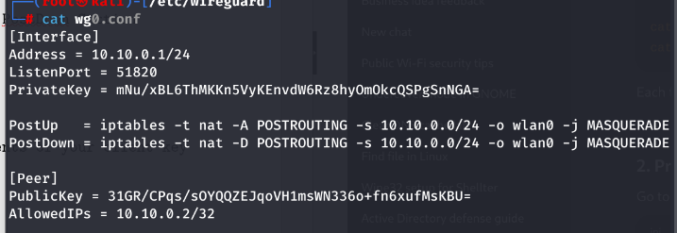
in the /etc/wireguard/wg0.conf add the lines below the PostDown Section
[Peer]
PublicKey = <client1_publickey>
AllowedIPs = 10.10.0.2/32

ensure to replace your client key with the actual contents of your client key you generated.
The peer section prepares the server to accept our client.

Restart WireGuard

sudo wg-quick down wg0
sudo wg-quick up wg0
sudo wg
where with the above done you should now see the peer listed

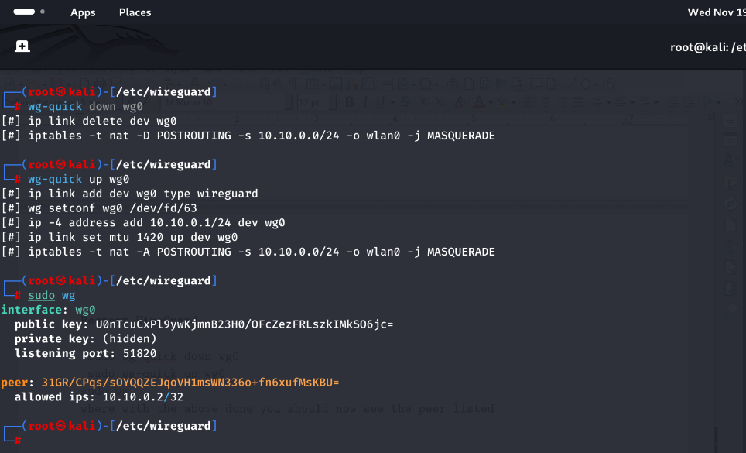

create a client configuration file

with the command sudo nano client1.conf

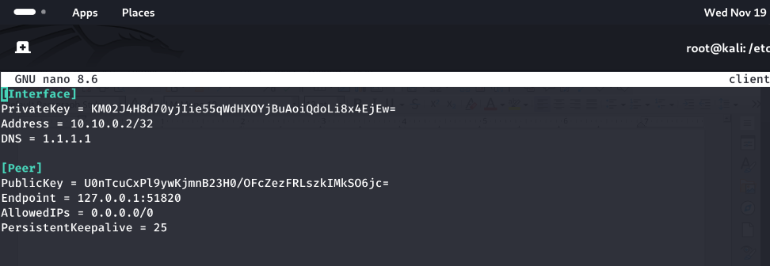

in the .conf paste for

[Interface]
PrivateKey = <client1_privatekey>
Address = 10.10.0.2/32
DNS = 1.1.1.1

[Peer]
PublicKey = <server_publickey>
Endpoint = <SERVER_PUBLIC_IP>:51820
AllowedIPs = 0.0.0.0/0
PersistentKeepalive = 25

and replace where relevant ie with <...>. Since the server will be running on your local kali machine fill the endpoint IP address as 127.0.0.1 which is you loopback IP address.

=> Ensure to run the command sudo systemctl enable wg-quick@client1 to start it on bootup
Starting the client
the command sudo wg-quick up client1 does it

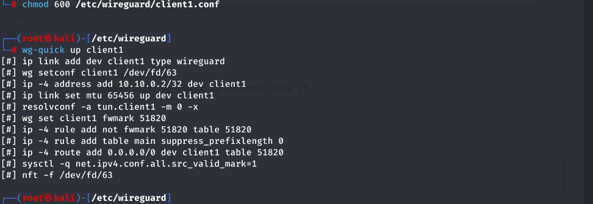

if faced by resolveconf
resoleconf: command not found

1. install resolve with
sudo apt install resolveconf -y

2. then try sudo wg-quick up client1

INSTALLING AND SETTING UP OPENVPN.

Update the system.
Good kali practice as mentioned is always updating and upgrading your system before any installation. As mentioned the command: sudo apt update updates the system while the command: sudo apt upgrade upgrades the system. Or combine the commands to: sudo apt update && sudo apt full-upgrade -y
this practice ensures that all packages which ion our case are[OpenVPN, Easy-SRA, Kernel, Networking tools] are in the latest stable versions.

Enabling IP forwarding.

To enable IP forwarding the command:

echo "net.ipv4.ip_forward = 1" | sudo tee /etc/sysctl.d/99-openvpn-forward.conf

sudo sysctl -p /etc/sysctl.d/99-openvpn-forward.conf

this allows our server to route IP traffic between our client and the internet.
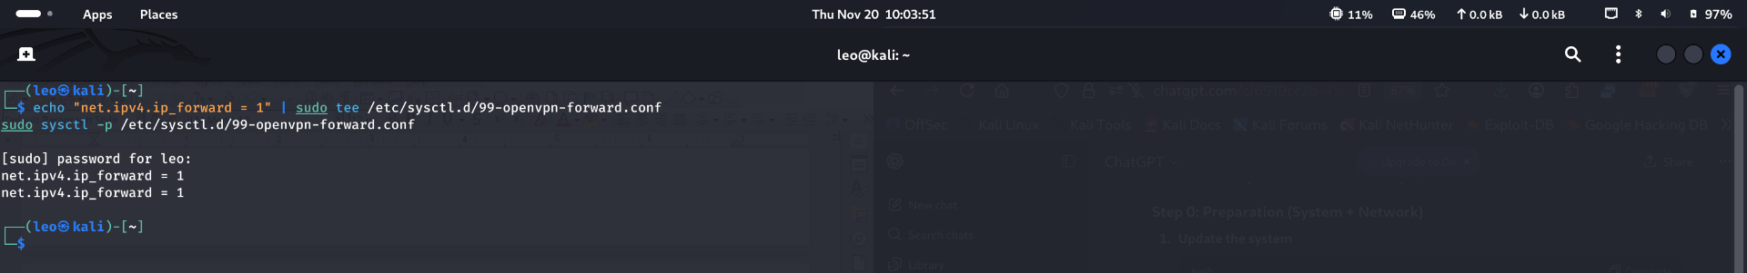

the expected output on tunning the command: sysctl -p … should be net.ipv4.ip_forward = 1.
Set up Network Address TranslatorTable/Iptables

the command:
sudo iptables -t nat -A POSTROUTING -s 10.8.0.0/24 -o wlan0 -j MASQUERADE

should do it. “A NAT masquerading rule was added so that OpenVPN client traffic (from the 10.8.0.0/24 subnet) exits via the server’s wlan0 interface, hiding client IPs behind the server.”


to save the rules to the IP tables and make them persistent use the command.

sudo apt install iptables-persistent
sudo netfilter-persistent save

this ensures that the NAT rule persistent across reboot.

Install OpenVPN and Easy-RSA
to install OpenVpn run the command
sudo apt install openvpn easy-rsa -y


Step 2: Set Up the Certificate Authority (CA)
- Create a directory for Easy-RSA:

the commands above creates the directory and navigates to it.

2. Initialize the PKI

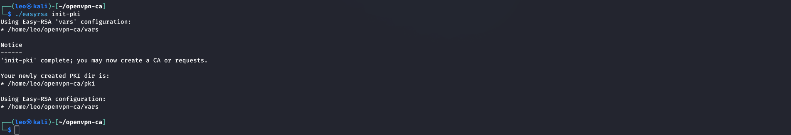
3. Build a Certificate Authority

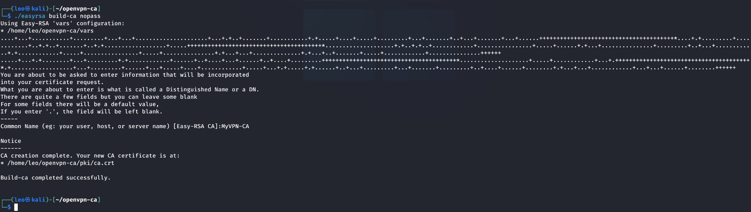
Easy-RSA’s PKI (Public Key Infrastructure) was initialized. A root CA certificate was generated (‘MyVPN-CA’) without a password to simplify automation, but private keys are stored securely. The nopass means no password hence making automation simpler but should be secure in an ideal setup.
Generate the server Certificate.
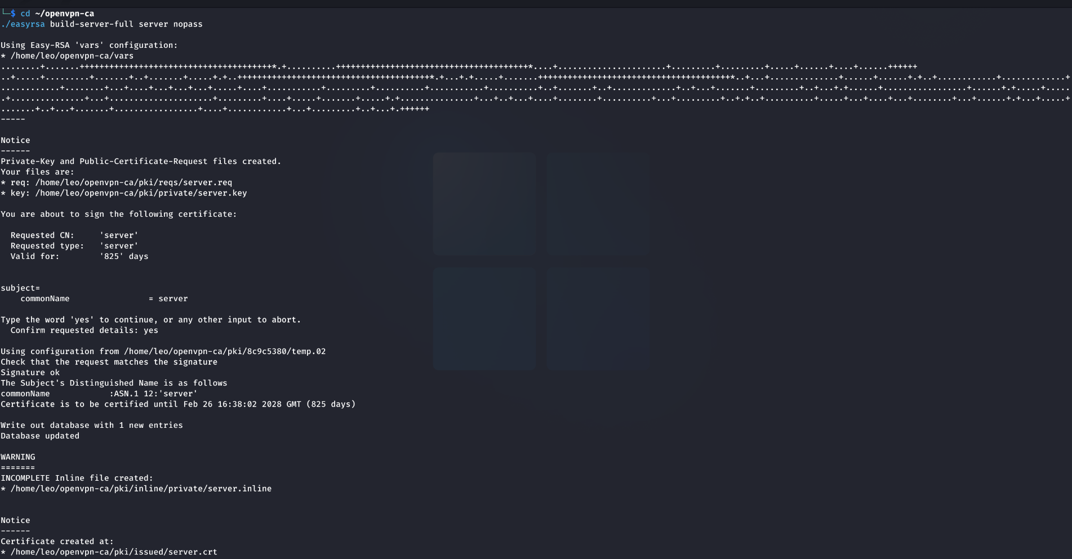
server is the name of the certificate.
nopass makes it unencrypted for startup ease.
A server certificate and private key were generated using Easy-RSA. These form the identity of our OpenVPN server.

Generating the Diffie-Hellman Parameter
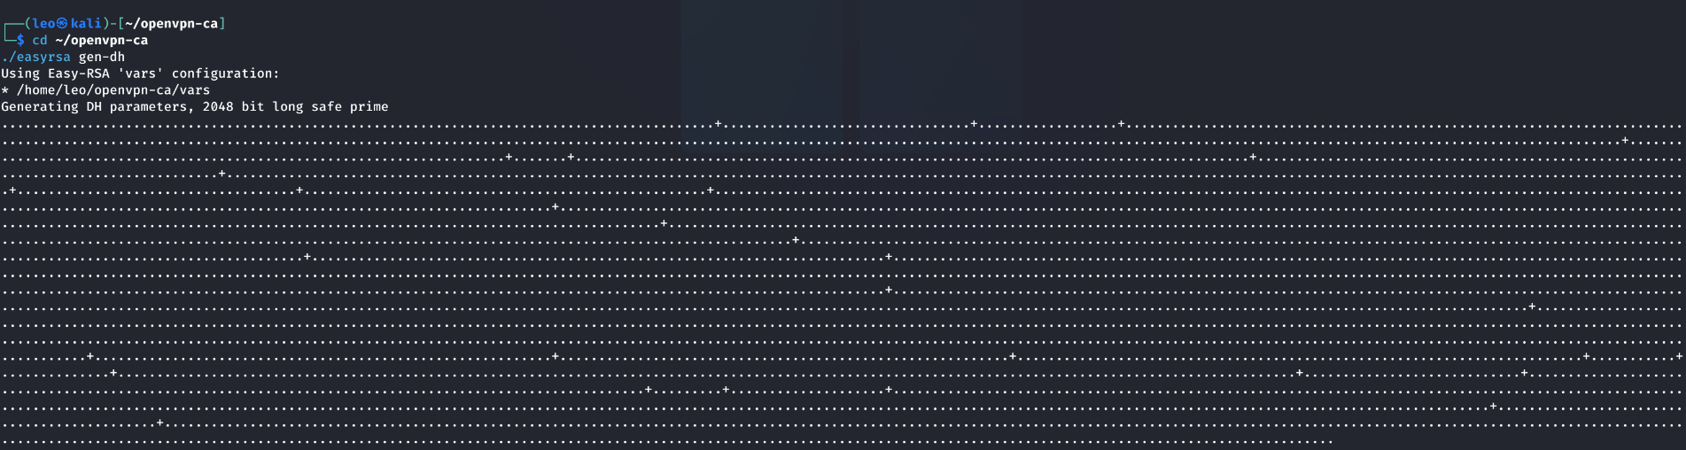
the Diffie-Hellman DH is generated to ensure for a secure key exchange between the clients and the server.
Copy ther materials to the OpenVPN directory in the /etc directory with the commands
sudo cp ~/openvpn-ca/pki/ca.crt /etc/openvpn/
sudo cp ~/openvpn-ca/pki/issued/server.crt /etc/openvpn/
sudo cp ~/openvpn-ca/pki/private/server.key /etc/openvpn/
sudo cp ~/openvpn-ca/pki/dh.pem /etc/openvpn/


All required cryptographic files (CA certificate, server certificate, private key, DH parameters) were copied to the OpenVPN directory for use by the service.
Generate the OpenVPN server configurations.
In the openvpn directory create a directory named server and a file named server.conf as per the image below.



In the server.conf paste the the code
port 1194
proto udp
dev tun
ca /etc/openvpn/ca.crt
cert /etc/openvpn/server.crt
key /etc/openvpn/server.key
dh /etc/openvpn/dh.pem

topology subnet
server 10.8.0.0 255.255.255.0

push "redirect-gateway def1"
push "dhcp-option DNS 1.1.1.1"

keepalive 10 120
persist-key
persist-tun

user nobody
group nogroup
verb 3
start and enable the openvpn
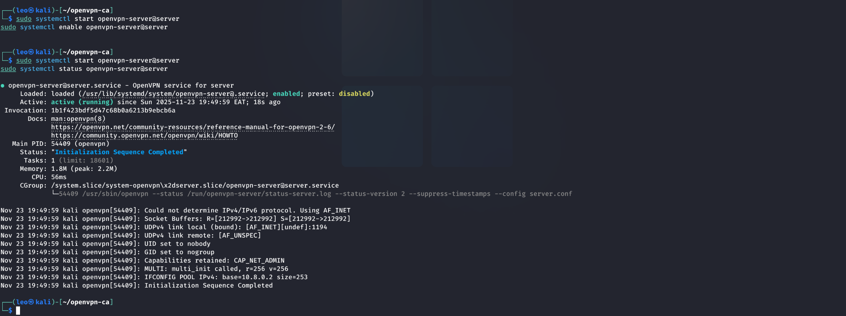
to start and enable run the commands

sudo systemctl start openvpn-server@server
sudo systemctl enable openvpn-server@server
and the command : sudo systemctl status openvpn-server@server to confirm

conformation.
If done correctly:
or running ip a command the results should be as

a tun0 for our OpenVPN, a wgo and client for our wireguard

and from the notification bar

Final System Summary
Once all components are active:
- The system acts as a dual-stack VPN router
- WireGuard provides fast encrypted tunneling
- OpenVPN provides certificate-based PKI security
- UFW enforces clean separation of services
- Both VPNs coexist without port or route conflict
- IPv4 forwarding allows full gateway functionality

